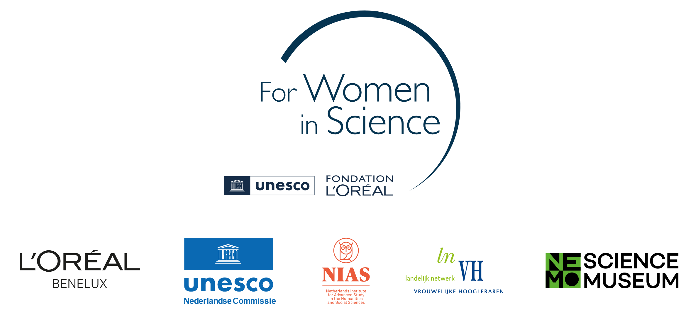

Project proposal form

Dutch L’Oréal-Unesco Fellowship For Women in Science 2025/2026

Provide a full description of the proposed project, presenting the items below. Elements 1 through 5 should take up a **maximum of 1500 words** (excl. references):

1. **Title of the proposed project**
2. **Research topic and research questions**
3. **Academic and societal relevance of the project**
4. **Description of the benefit of carrying out the project at** [**NIAS-KNAW**](https://nias.knaw.nl/what-we-offer/what-nias-offers/) **for both the proposed project *as well as* the benefit for NIAS-KNAW’s interdisciplinary research community (max. 300 words)**

Outline how a Fellowship at NIAS-KNAW is of added value and of importance to your proposed project, bearing in mind the key aims of the project. In your description, specify why the interdisciplinary research climate of NIAS-KNAW and the interaction with other fellows will be relevant to your work. Describe your intended involvement in the NIAS-KNAW community.

1. **Prospection of the potential impact of the Fellowship on the applicant’s academic career (max. 150 words)**

Explain what the potential impact of the FWiS Fellowship could be on your career.

1. **Proposed work plan, including activities, time schedule and a budget summary**

Please provide a work plan for the Fellowship at NIAS-KNAW.

Include in the work plan the proposed activities to be carried out and a time schedule reflecting these activities.

Using the table below, include a budget summary in support of this work plan.

*The total budget available is € 30,000. For the first two elements (NIAS-KNAW facilities and Replacement costs) the amounts are fixed. Before you do fill in the table, please consult the Appendix of the regulations, which includes instructions and standard rates.*

|  |  |  |
| --- | --- | --- |
| **Budget item** | **Per month** | **Total 5 months** |
| NIAS-KNAW facilities | € 2,100 | € 10,500 |
| Replacement costs | € 2,500 | € 12,500 |
| Travel costs | ? |  |
| Additional childcare costs | ? |  |
| NIAS-KNAW workshop | ? |  |
| **Total** |  | **€ 30,000** |

**Please note that applying for housing will have an impact on your budget summary. In case you are applying for housing, contact Annette Mullink at NIAS-KNAW for help with your budget summary:** [**selection@nias.knaw.nl**](mailto:selection@nias.knaw.nl)**.**

1. **Summary of the project in plain language (max. 150 words)**

Provide a concise description of the research project in plain language. The summary should clearly explain the main objective and significance of the project in a way that is understandable to an interested layperson.